**EE387: Signal Processing**

**Lab 1: Basic Signal Representation and Convolution in MATLAB**

Ranage R.D.P.R. - E/19/310

**PART 1: Basic Signal Representation in MATLAB**

**1. Write a Matlab program and necessary functions to generate the following signal:**

**y(t) = r(t+3) – 2r(t+1) +3r(t) – u(t-3)**

**Then plot it and verify analytically that the obtained figure is correct.**

clear all;

Ts=0.01;

t= -5:Ts:5;

y1 = ramp(t,3,3);

y2 = ramp(t,-6,1);

y3 = ramp(t,3,0);

y4 = ustep(t,-3);

y = y1-2*y2+3*y3-y4;

plot(t, y, 'k');

axis([-5 5 -1 7]);

grid

function y = ramp(t, m, ad)

% t: length of time

% m: slope of the ramp function

% ad: advance (positive), delay (negative) factor

t = t(:)';

% Initialize y

y = zeros(size(t));

% Find the indices where t >= -ad

idx = find(t >= -ad);

% Calculate ramp function

y(idx) = m * (t(idx) + ad);

end

function y = ustep(t, ad)

% t: length of time

% ad: advance (positive), delay (negative) factor

t = t(:)';

y = zeros(size(t));

% Find the indices where t >= -ad

idx = t >= -ad;

% Set the values to 1 where t >= -ad

y(idx) = 1;

end

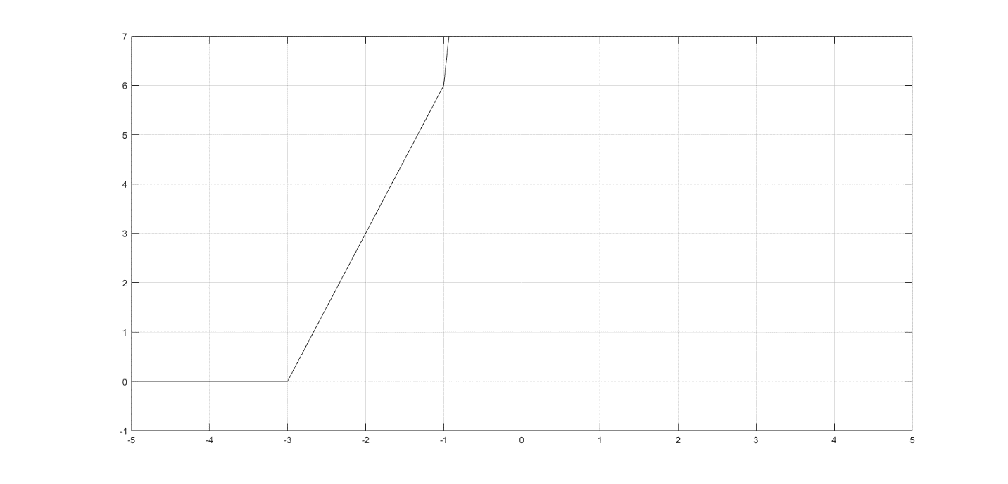

**2. For the damped sinusoidal signal x(t) = 3e-tcos(4πt) write a MATLAB program to generate x(t) and its envelope, then plot.**

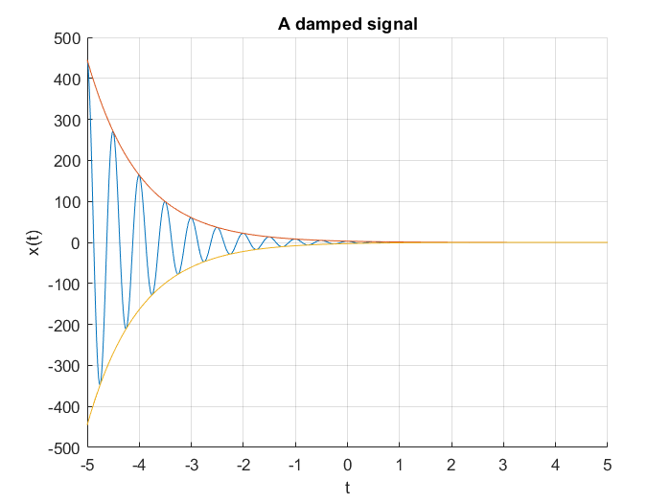clear all;

close all;

clc;

Ts=0.01; %Sampling time

t=-5:Ts:5; %Time vector

x= 3 * exp(-1*t) .* cos(4*pi*t);

envelope= 3 * exp(-1*t);

figure;

hold on;

plot(t,x);

plot(t, envelope);

plot(t, -1*envelope);

title('A damped signal');

xlabel('t');

ylabel('x(t)');

grid

**PART 2: Time-Domain Convolution**

**Creating a rectangular pulse in MATLAB**

f_s = 100;

T_s = 1/f_s;

t = [-5:T_s:5];

x1 = rect(t);

subplot(3,1,1);

plot(t,x1);

axis( [-2 2 -1 2]);

title ('Plot 1: A rectangular pulse');

xlabel( 'time (sec)' ) ;

ylabel( 'x_1(t)' ) ;

grid on;

x2 = rect(t-1);

subplot(3, 1, 2);

plot(t,x2);

axis( [-2 2 -1 2]);

title ('Plot 2: time-delayed rectangular pulse');

xlabel( 'time (sec)' ) ;

ylabel( 'x_2(t)' ) ;

grid on;

x3 = rect(t/2);

subplot(3, 1, 3);

plot(t,x3);

axis( [-2 2 -1 2]);

title ('Plot 3: time-scaled rectangular pulse');

xlabel( 'time (sec)' ) ;

ylabel( 'x_3(t)' ) ;

grid on;

% Define rectangular pulse function

function x = rect(t)

%

% RECT rectangular pulse

%

% Usage: x = rect(t)

%

% This function takes in a vector t of sample instants and outputs the

% corresponding rectangular pulse contained in the function x

x = (abs(t) <= 0.5);

end

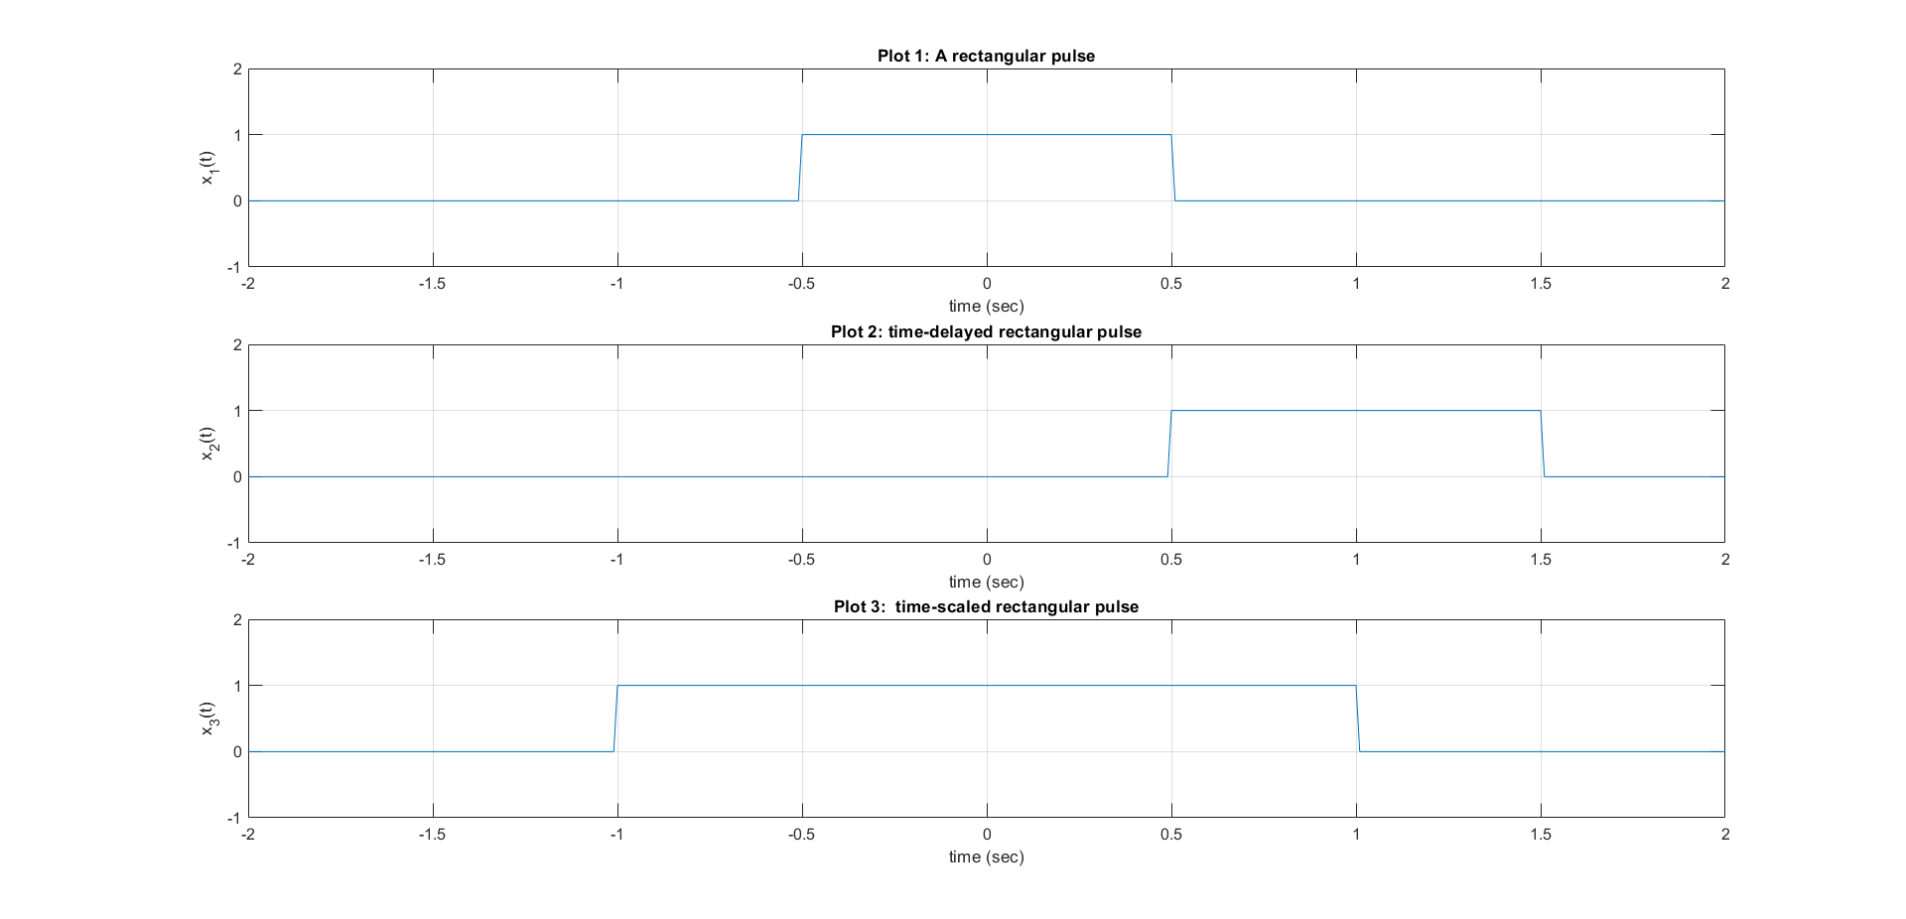

f_s = 100;

T_s = 1/f_s;

t = [-5:T_s:5];

x4 = rect(t) + (1/2) * rect(t-1);

subplot(3,1,1);

plot(t,x4);

axis( [-2 2 -1 2]);

title ('Plot 1: A rectangular pulse');

xlabel( 'time (sec)' ) ;

ylabel( 'x_1(t)' ) ;

grid on;

x5 = rect(-t) + (1/2) * rect(-t-1);

subplot(3, 1, 2);

plot(t,x5);

axis( [-2 2 -1 2]);

title ('Plot 2: time-delayed rectangular pulse');

xlabel( 'time (sec)' ) ;

ylabel( 'x_2(t)' ) ;

grid on;

x6 = rect(1-t) + (1/2) * rect(-t);

subplot(3, 1, 3);

plot(t,x6);

axis( [-2 2 -1 2]);

title ('Plot 3: time-scaled rectangular pulse');

xlabel( 'time (sec)' ) ;

ylabel( 'x_3(t)' ) ;

grid on;

% Define rectangular pulse function

function x = rect(t)

%

% RECT rectangular pulse

%

% Usage: x = rect(t)

%

% This function takes in a vector t of sample instants and outputs the

% corresponding rectangular pulse contained in the function x

x = (abs(t) <= 0.5);

end

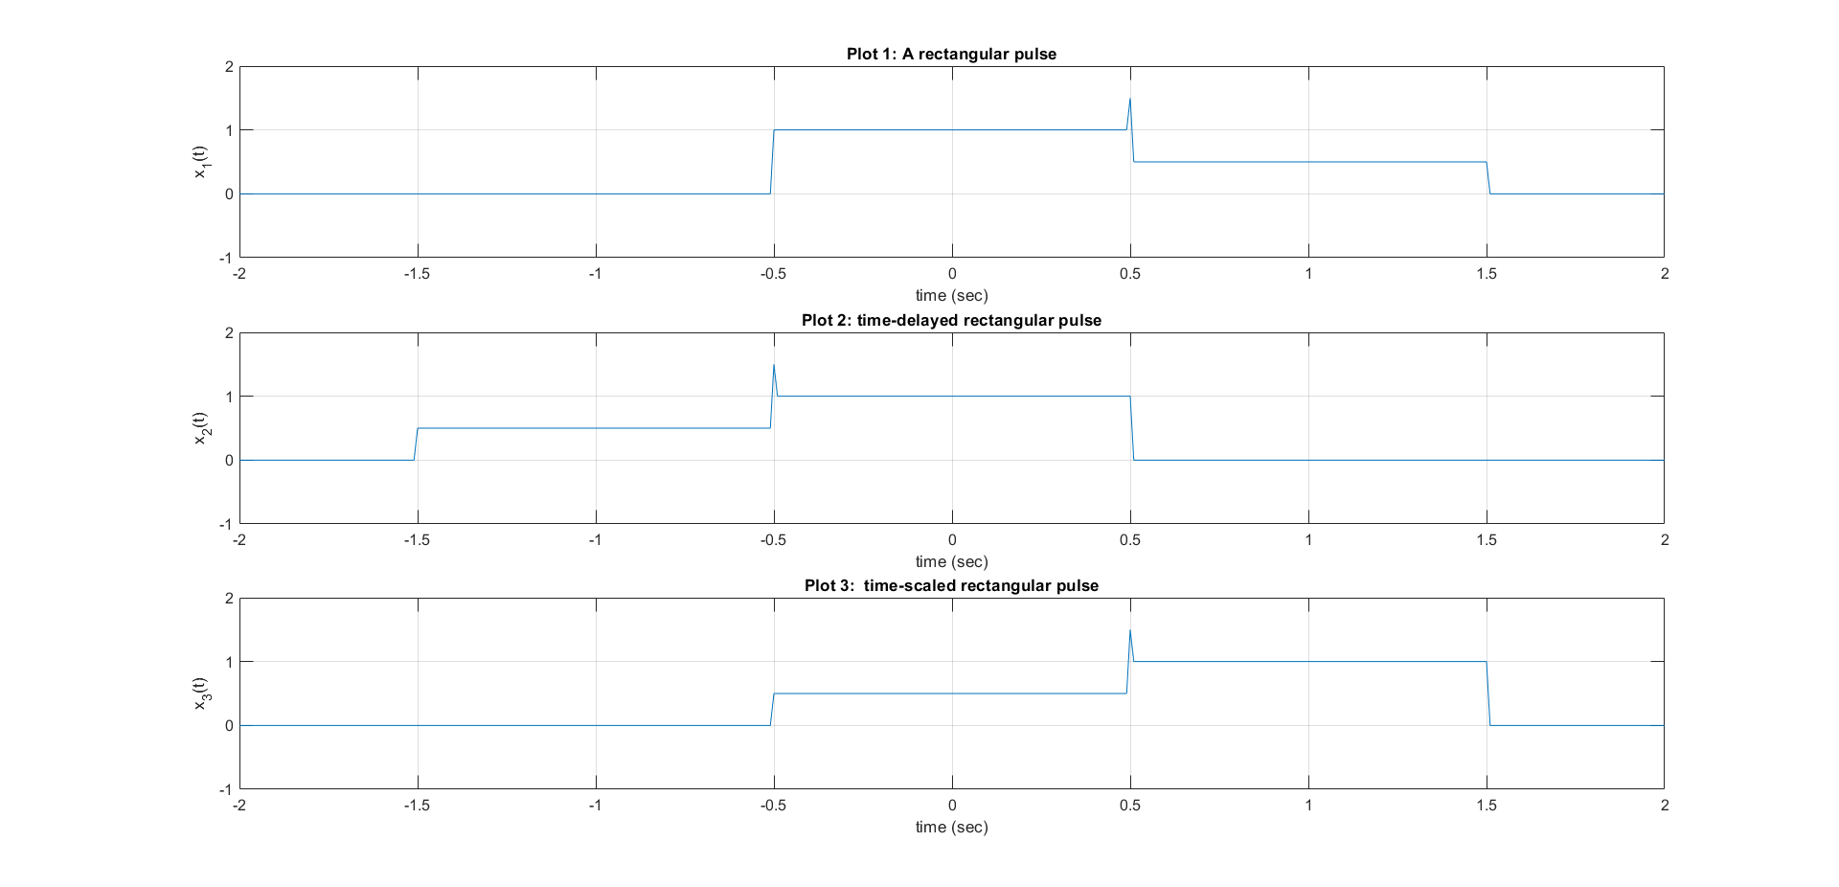

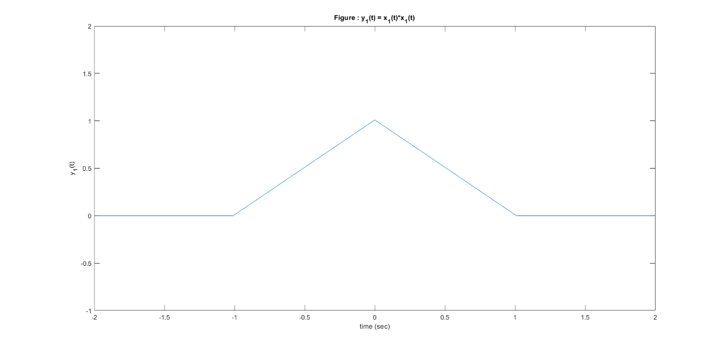y = conv(x1,x1);

close all;

%plot ( t, y);

length(y)

length(t)

t_y = -10:T_s:10;

plot( t_y, y);

y1 = T_s*conv(x1,x1);

plot(t_y, y1);

axis( [-2 2 -1 2] ) ;

xlabel( 'time (sec)');

ylabel('y_1(t)');

title('Figure : y_1(t) = x_1(t)*x_1(t)');

**Exercise**

**1. Perform convolution on discrete time signals x(n) and h(n), i.e., y(n) = x(n)*h(n) using MATLAB. For each set of signals, plot x(n), h(n) and y(n) as subplots in the same figure.**

**• x(n) = { 1,2,4 }, h(n) = {1,1,1,1,1}**

**• x(n) = { 1,2,3,4,5 }, h(n) = {1}**

**• x(n) = h(n) ={ 1,2,0,2,1}**

% Define the signals

x1 = [1, 2, 4];

h1 = [1, 1, 1, 1, 1];

x2 = [1, 2, 3, 4, 5];

h2 = [1];

x3 = [1, 2, 0, 2, 1];

h3 = [1, 2, 0, 2, 1];

% Perform convolution

y1 = conv(x1, h1);

y2 = conv(x2, h2);

y3 = conv(x3, h3);

% Plot the signals and convolution results

figure;

% Subplot for x1(n)

subplot(3, 3, 1);

stem(0:length(x1)-1, x1);

title('x1(n)');

xlabel('n');

ylabel('Amplitude');

% Subplot for h1(n)

subplot(3, 3, 2);

stem(0:length(h1)-1, h1);

title('h1(n)');

xlabel('n');

ylabel('Amplitude');

% Subplot for y1(n)

subplot(3, 3, 3);

stem(0:length(y1)-1, y1);

title('y1(n)');

xlabel('n');

ylabel('Amplitude');

% Subplot for x2(n)

subplot(3, 3, 4);

stem(0:length(x2)-1, x2);

title('x2(n)');

xlabel('n');

ylabel('Amplitude');

% Subplot for h2(n)

subplot(3, 3, 5);

stem(0:length(h2)-1, h2);

title('h2(n)');

xlabel('n');

ylabel('Amplitude');

% Subplot for y2(n)

subplot(3, 3, 6);

stem(0:length(y2)-1, y2);

title('y2(n)');

xlabel('n');

ylabel('Amplitude');

% Subplot for x3(n)

subplot(3, 3, 7);

stem(0:length(x3)-1, x3);

title('x3(n)');

xlabel('n');

ylabel('Amplitude');

% Subplot for h3(n)

subplot(3, 3, 8);

stem(0:length(h3)-1, h3);

title('h3(n)');

xlabel('n');

ylabel('Amplitude');

% Subplot for y3(n)

subplot(3, 3, 9);

stem(0:length(y3)-1, y3);

title('y3(n)');

xlabel('n');

ylabel('Amplitude');

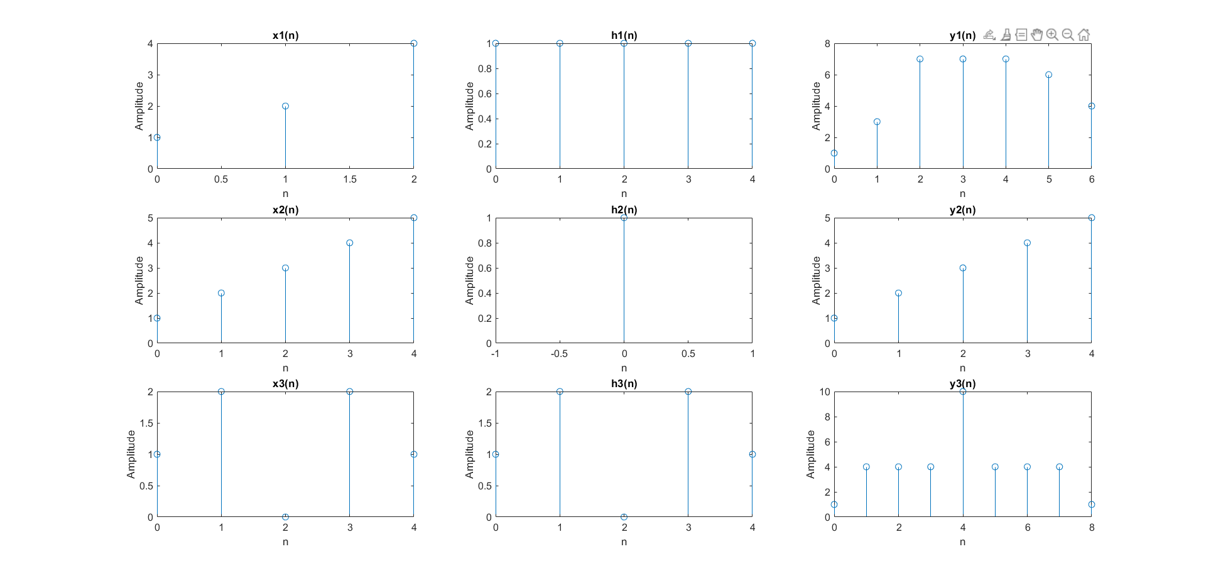

**2. Assume a system with the following impulse response:**

**h(n) = (0.5)n for 0<= n < 4**

**= 0 elsewhere**

**Determine the input x (n) that will generate the output sequence**

**y(n) = {1, 2, 2.5, 3, 3, 3, 2,1,0...}**

**Plot h(n), y (n) and x (n) in one figure.**

clear all;

n=0:3;

h=0.5.^n;

y=[1, 2, 2.5, 3, 3, 3, 2, 1, 0, 0, 0, 0, 0, 0, 0, 0 ];

[x,R]=deconv(y,h);

figure

subplot(3,1,1);

stem(h);

title('Impulse response');

xlabel('n');

ylabel('h(n)');

subplot(3,1,2);

stem(y);

title('Output');

xlabel('n');

ylabel('y(n)');

subplot(3,1,3);

stem(x);

title('Input');

xlabel('n');

ylabel('x(n)');

